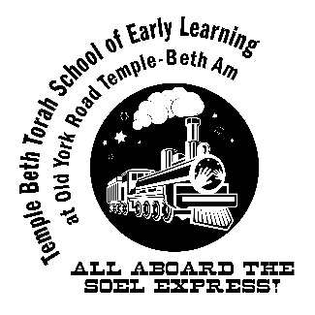
SOEL Camp 2023
June 12- August 18

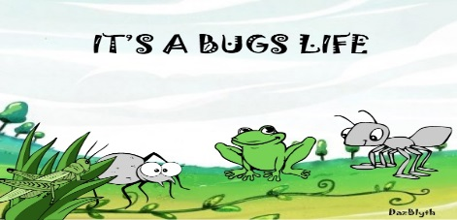

Weeks 1 & 2 – It’s a Bugs Life

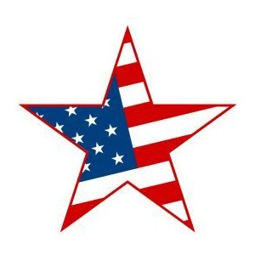

Week 3 – Stars & Stripes
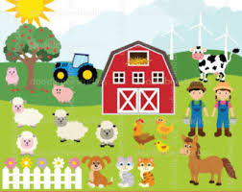

Weeks 4 & 5- Down on the Farm

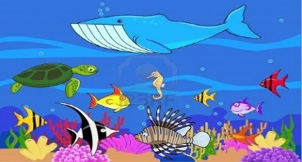
Weeks 6 & 7 – Animals in the Ocean
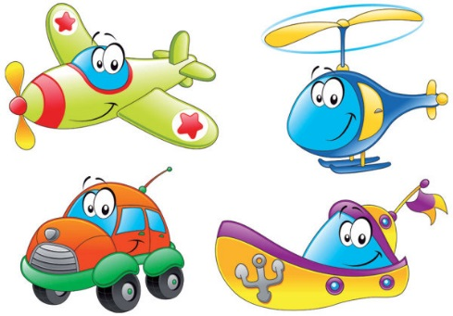

Weeks 8 & 9- On the Go!
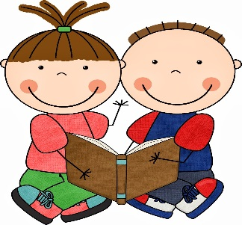
This Photo by Unknown Author is licensed under CC BY-NC-ND

Week 10- Lovin’ Literature

