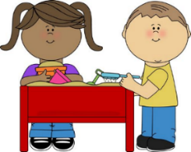
Camp Themes 2022
Week 1 - Sunny Summer Sensory Play
(June 13 – 17)
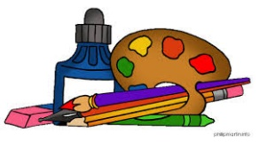
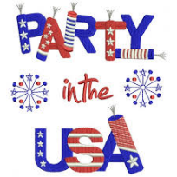
Week 2- Color Craze
(June 20 – 24)
Week 3- Party in the USA
(June 27 – July 1)
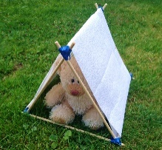
Week 4- Teddy Bear Camping Adventure
Closed July 4
(July 5- July 8)
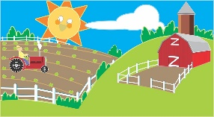
Weeks 5 & 6 – Down on the Farm
(July 11 – July 22)
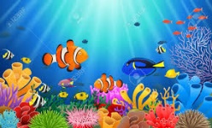
Weeks 7 & 8 - Under the Sea
(July 25 – August 5)
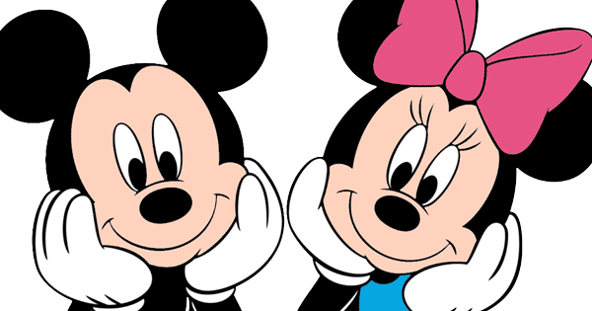
Week 9 – Disney Week
(August 8- August 12)
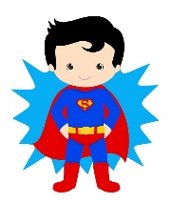
Week 10- Community Helper/Superhero week
(August 15- August 19)

Morning Specials Camp Specials
Monday- Sports Movin’ Mondays
Tuesday- Art SOEL T-Shirt Tuesdays
Wednesday- Exploration Stations Wacky Wednesdays
Thursday- Music Treat Day Thursdays
Friday- Story Shabbat Fridays

